**Provider Tutorial Gr-resQ tool + OSCM**

**Author:** Ricardo Toro

**Version:** 1.0.0

**Date:** 08/02/2019

**Description:**

This tutorial will guide you on the process of managing a transaction (experiment) using the Gr-reQ tool and the OSCM platform. This tutorial is from the provider perspective.

A provider is the person who runs a transaction or experiment in a CVD furnace. The transaction is created by a customer and shared with the provider. All results coming from the experiment will be attached to the transaction, so the customer could use them for further analysis.

**Workflow:**

1. Create an OSCM account.
2. Provide CDV facility access to the customer.
3. Manage a transaction (experiment).
4. Attach results to a completed transaction.

**Steps:**

1. Create an OSCM account:

There are two ways of creating an OSCM account: a) from the official OSCM website (<https://oscm-il.mechse.illinois.edu/>) or b) using the Gr-resQ tool.

a) From OSCM:

* Open your Chrome browser and go to <https://oscm-il.mechse.illinois.edu/>
* Click on **Register** button.
* Fill in all required information. The only field that you do not need to fill out is the **“User Accounts”** field.
* To verify your new user account, access your email mailbox (the one that you provided when registering).
* Find the email sent by OSCM in your mailbox. Click on the provided link. Then, you are all set.

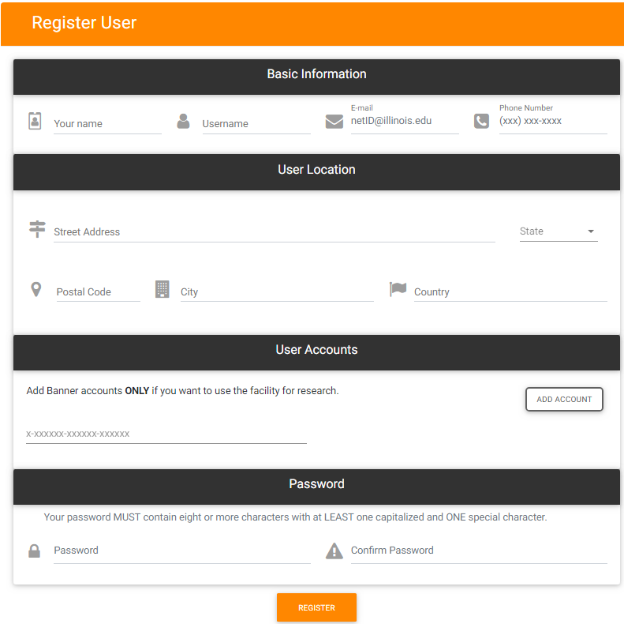

Figure : User registration from OSCM website

b) From Gr-resQ tool:

* Open the Gr-resQ tool.
* Click on **OSCM** tab. Then click on **Register** button.
* Fill in all required information. Then, click on **Submit** button.

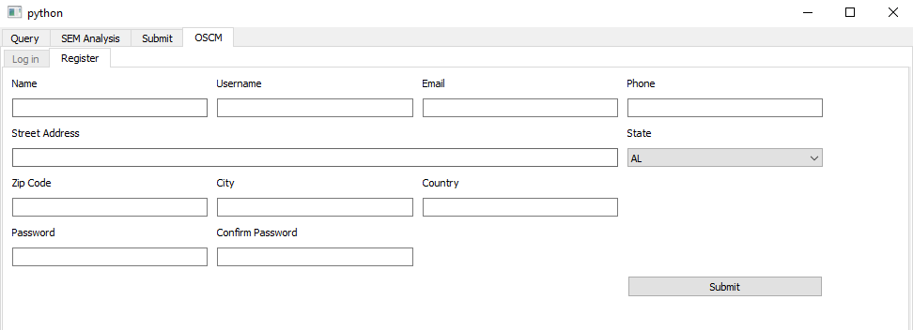

Figure : User registration from Gr-resQ tool

* To verify your new user account, access your email mailbox (the one that you provided when registering).
* Find the email sent by OSCM in your mailbox. Click on the provided link. Then, you are all set.

1. Provide CDV facility access to the customer.

* Open your Chrome browser and go to <https://oscm-il.mechse.illinois.edu/>
* Log in with your OSCM credentials.
* In the **MY RESOURCES** tab, find your facility. Click on **details**.

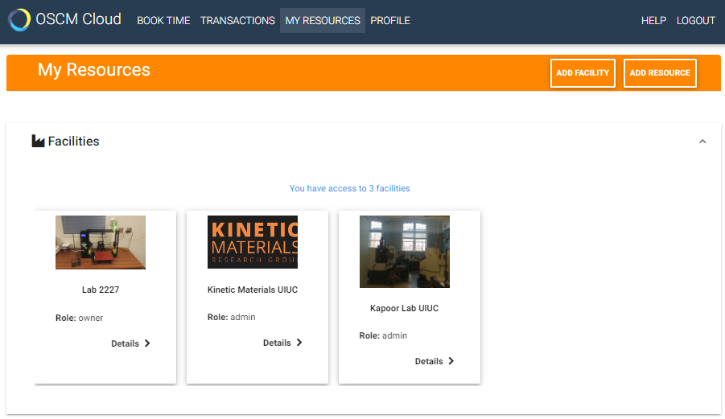

Figure : Find facility

* Click on **Users** tab, and then click on **Invite Users** button.

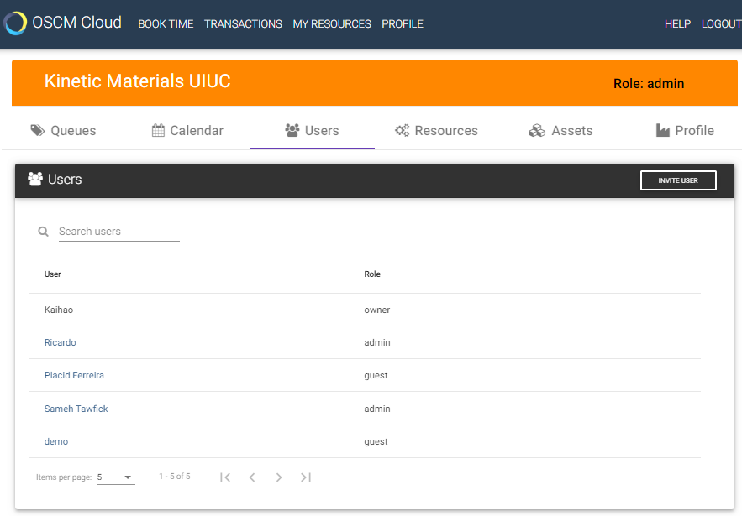

Figure : Users Tab

* Write down the username of the customer in the **Username** field. Select the **Guest** role in the **select role** dropdown. Finally, click on **Invite User** button.

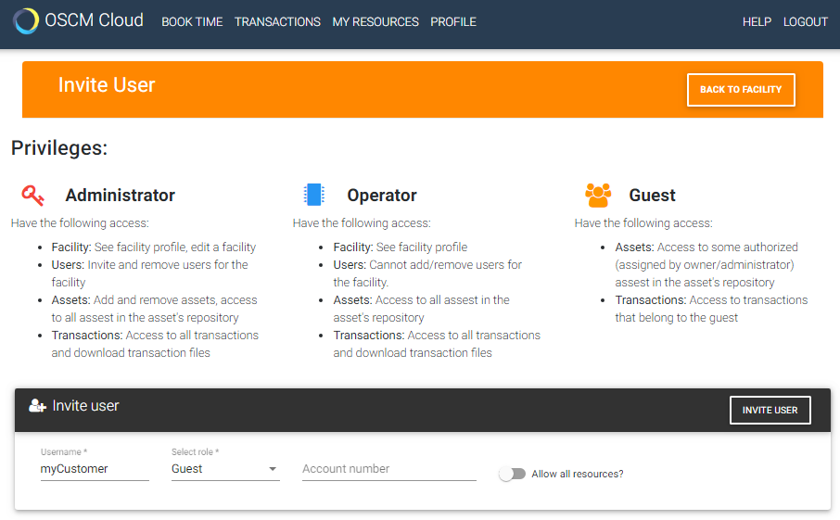

Figure : Complete customer invitation

1. Manage a transaction (experiment):

* Open your Chrome browser and go to <https://oscm-il.mechse.illinois.edu/>
* Log in with your OSCM credentials.
* In the **MY RESOURCES** tab, find your facility. Click on **details**.
* Click on the queue that you want manage. Then, all transactions are organized by status. The possible status for a transaction are: requested, accepted, in progress, completed, declined or cancelled.
* Click on any transaction for more details.
* To change the status of a transaction click on the status button of your desired. Example: if you want to approve a transaction, click on **Approve** button.

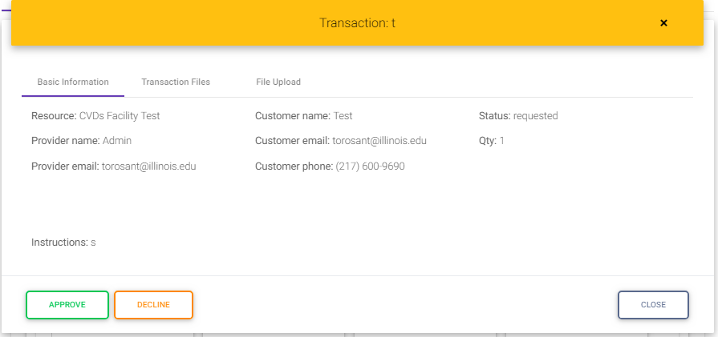

Figure : Manage transaction (Accept transaction)

* If you want to decline a transaction, click on **decline** button. Then, select the reason from the listed options. If there is not an option that satisfies the reason of declining the transaction, click other and then provide more details.

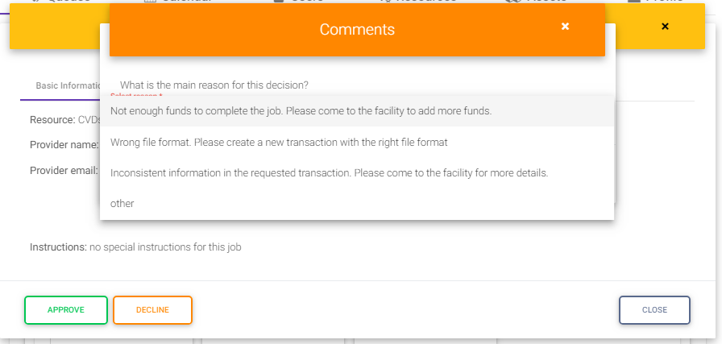

Figure : Decline a transaction

* If you want to download the recipe file, click on **Transaction Files** tab. Then, click on **download** button. Save the file in any directory of your local computer.

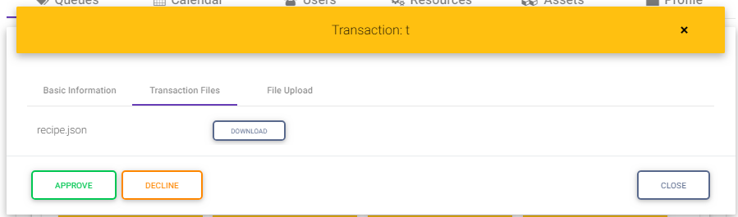

Figure : Manage transaction (Download file)

1. Attach results to a completed transaction:
   * If you want to attach any file after you completed the experiment, click on **File Upload** tab. Then click on **Choose Files** button. Browse and select the files in your local computer. Then, click on **Upload** button for each file.

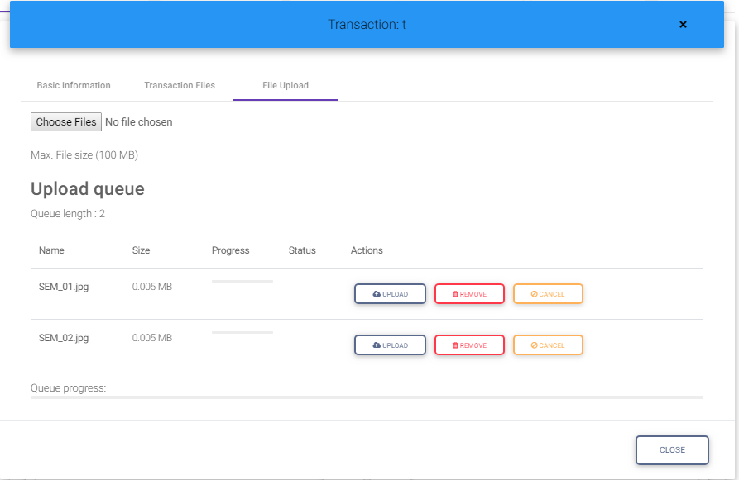

Figure : Attach files to the transaction